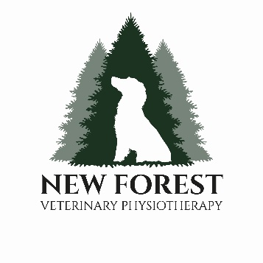
New Forest Veterinary Physiotherapy
Referral Form
Owner’s Details

Name:
Address:
Telephone: |  | Mobile Tel:
Email:

I have read and fully accept New Forest Veterinary Physiotherapy’s terms and conditions and I consent to my animal receiving physiotherapy treatments by Carlie Dixon and will pay the full amount for treatment on the day or in advance.
A 50% cancellation fee applies without 24 hours’ notice.
Owners signature : Date:

Animal’s Details

Name:
Breed: |  | Age:
Neutered: |  | Sex:
Diagnosis:
Medication:
Vaccinations:
Pre-existing conditions:
I consent to this animal having musculoskeletal checks and physiotherapy treatment where appropriate. In your opinion this animal is fit to receive physiotherapy treatments. Valid for a period of 3 months / 6 months / 1 year / indefinitely (please circle)
Veterinary Practice Details

Practice Name:
Address:
Telephone:
Email:
Vet’s Name: | (Print)
Vet’s Signature: |  | Date:

Please note initial veterinary physiotherapy reports are sent following the ^{4th} appointment with the client and then on a 3 monthly basis for regular patients. Should you require more regular reports, please contact me in advance.
New Forest Small Animal Rehabilitation limited and New Forest Veterinary Physiotherapy.
Newforestvetphysio@gmail.com| 07786178072 |FB: New Forest Veterinary Physiotherapy. Carlie Dixon Prof Dip SAPhys, CERT3 RCH, OA DIP,

